

MATHEMATICS 2CMAT/2DMAT SAMPLE EXAMINATION

RESOURCE-RICH
This sample examination paper was developed early in 2007 and distributed to all Mathematics teachers as part of the formal consultation process (April–May 2007). The purpose was to provide teachers with an example of how the course syllabus could be examined—specifically the scope, style and difficulty level of the questions that might be asked in a typical Mathematics 2C/2D WACE examination.

The sample paper has been further refined following consultation with teachers, measurement specialists and advice from the Assessment, Review and Moderation (ARM) panel. The major change is that the paper has been divided into two parts--a resource-free examination of 50 minutes, worth 40 marks, and a resource-rich examination of 100 minutes, worth 80 marks.

0000.doc




Western Australian Certificate of Education, Sample External Examination
Question/Answer Booklet

MATHEMATICS
2CMAT/2DMAT
Please place one of your student identification labels in this box.
WRITTEN PAPER
RESOURCE-RICH

Time allowed for this paper
Reading time before commencing work: Ten minutes
Working time for paper: One hour and forty minutes

Material required/recommended for this paper

To be completed by candidates

What kind(s) of calculator did you bring to this examination?

Make and model:
1.

2.
None  (tick if applicable)

To be provided by the supervisor
This Question/Answer Booklet

To be provided by the candidate
Standard items: Pens, pencils, eraser, correction fluid, ruler,
highlighter

Special items: Curriculum Council Mathematical Formulae and Statistical Tables Book, drawing instruments, templates, notes on TWO unfolded sheets of A4 paper and calculators satisfying the conditions set by the Curriculum Council for this subject.
Note: Personal copies of the Tables Book should not contain any handwritten or typewritten notes, symbols, signs, formulae or any other marks (including underlining and highlighting) except a name and address, and may be inspected during the examination.

Important note to candidates
No other items may be taken into the examination room. It is your responsibility to ensure that you do not have any unauthorised notes or other items of a non-personal nature in the examination room. If you have any unauthorised material with you, hand it to the supervisor before reading any further.

This paper is for students who have completed Units 2CMAT and 2DMAT as their last pair of units.
Structure of this paper

Working time | Number of questions available | Number of questions to be attempted | Marks
100 minutes | 10 | 10 | 80
 |  | [Total marks] | 80

This paper has TEN (10) questions. Attempt ALL questions.

Question | Marks
1 | 6
2 | 6
3 | 13
4 | 5
5 | 8
6 | 8
7 | 8
8 | 10
9 | 6
10 | 10
Total marks | 80

Instructions to candidates

1. The rules for the conduct of Curriculum Council examinations are detailed in the Student Information Handbook. Sitting this examination implies that you agree to abide by these rules.

2. Write your answers in the spaces provided in this Question/Answer Booklet. Spare pages may be found at the end of the booklet. If you need to use them, indicate in the original answer space where the answer is continued (i.e. give the page number).

3. A blue or black ballpoint or ink pen should be used.

4. It is recommended that you do not use pencil except in diagrams.

5. Show all your working clearly. Your working should be in sufficient detail to allow your answers to be checked readily and for marks to be awarded for reasoning. Correct answers given without supporting reasoning may not be allocated full marks. Incorrect answers given without supporting reasoning cannot be allocated any marks. If you repeat an answer to any question, ensure that you cancel the answer you do not wish to have marked

6. On the front cover you are asked to state the kinds of calculator that you brought into the examination. This information is required to ensure the examination is fair for all students. Please complete the box. Note that the same marking procedure will apply to all scripts, whatever calculator you use.

RESOURCE-RICH

This paper has TEN (10) questions. Attempt ALL questions.

Question 1 [6 marks]
The ‘average’ price of houses sold in various suburbs during the month is often quoted in a Sunday newspaper. Usually only a small number of houses are sold each month in each suburb and the median is used as the average.

- For the suburb of Riverton, six houses were sold in January. The prices were:

$180 000 | $200 000 | $165 000 | $210 000 | $175 000 | $220 000

For these prices, find the
- mean
[1 mark]

- median
[1 mark]

- For the suburb of Como, five houses were sold in May. For these five houses the median price was $330 000. The mean, if calculated, would not be a good ‘average’ of the five house prices.

Give an example of the five prices that fit this description.
[2 marks]

- Explain why the median is generally a better representative value than the mean for this type of data.
[2 marks]

Question 2 [6 marks]
Maria is learning a foreign language. She has already learnt 31 words. She now sets herself the task of learning 8 new words a day.

- What is the total number of words she will have learnt after:
- 7 days?
[1 mark]

- n days?
[1 mark]

- Use algebraic recursive notation to describe:
- T_{n}, the total number of words she will have learnt after n days.
[2 marks]

- T_{w}, the total number of words she will have learnt after w weeks.
[2 marks]

THIS SPACE HAS BEEN LEFT BLANK INTENTIONALLY

THIS PAGE HAS BEEN LEFT BLANK INTENTIONALLY

Question 3 [13 marks]
Access to the internet has been of great interest in recent years. The Australian Bureau of Statistics published the following table of information in the Year Book Australia 2003. This data is from a large sample.

CHILDREN ACCESSING THE INTERNET (a)(b)– April 2000 (c)

Site of internet access (d)
 | Home | School | Someone else’s home | Public library | Any site
 | % | % | % | % | %
Age groups (years)
5-8 | 12 | 12 | 3 | 1 | 22
9-11 | 30 | 37 | 10 | 3 | 55
12-14 | 42 | 51 | 19 | 7 | 72
Sex
Males | 27 | 32 | 10 | 4 | 47
Females | 25 | 30 | 9 | 3 | 46
Region
Capital cities | 28 | 30 | 10 | 3 | 47
Rest of Australia | 23 | 33 | 10 | 4 | 47
All children | 26 | 31 | 10 | 3 | 47

(a) Children were aged 5-14 years. (b) Proportions are of all children in each category. (c) Internet access occurred during the preceding 12 months. (d) Children may have accessed the internet at only one or any number of sites.
(Australian Bureau of Statistics, 2003)

- Give TWO (2) different reasons for having confidence in the data in the table.
[2 marks]

- Describe as precisely as you can the meaning of the 37 in the second column of figures in the table.
[3 marks]

- What percentage of the children (aged 5-14 years) did not access the internet over the twelve months represented in the table?
[1 mark]

- Describe, in detail, the internet access of the 9-11 year olds.
[3 marks]

- Explain how to use the table to conclude that some students must have accessed the internet both at home and at school.

[2 marks]

- What conclusions can you draw from the table about a relationship between internet access and age of children? Justify your answer.
[2 marks]

Question 4 [5 marks]

- Greg simulated 20 rolls of a fair eight-sided die and averaged the results of the rolls. He repeated this process two times. Give examples of the averages that he is likely to produce and justify your choices.
[3 marks]

- Next Greg simulated 200 rolls of the die and averaged the results of the rolls. Describe how averages produced in this way are likely to be different from those in part (b). Justify your answer.

[2 marks]

THIS PAGE HAS BEEN LEFT BLANK INTENTIONALLY
Question 5 [8 marks]
The network below represents a distribution network linking 10 centres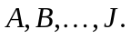 The number on each edge represents the distance in km between the two centres it joins.
B 70 G
D 45 F 15 I
C H
A
J
20 40 30 25
30 15 30 10 30 15 30
15 35
40 20 45 12
E

- Find the shortest path from A to J and state its length.

[3 marks]

- Find the shortest path from A to J that passes through D. What is the length of this path?
[2 marks]

- A bypass under construction will reduce the distance along the section connecting centres I and J by x km. For what values of x will the shortest path from A to J use the bypass?

[3 marks]

THIS SPACE HAS BEEN LEFT BLANK INTENTIONALLY

Question 6 [8 marks]
There is a loan product on the market called a Reverse Mortgage, in which money may be borrowed against the assessed value of your house. No repayments are made on the money borrowed until the house is sold.

Consider the situation where $45 000 was borrowed and the interest rate was 8% per annum.

- The table below shows the annual interest and the total amount owing after t years. Complete the last two rows.
[2 marks]

Year (t) | Interest ($) | Amount owing ($)
1 | 3 600.00 | 48 600.00
2 | 3 888.00 | 52 488.00
3
4

- What amount would be owed after 20 years?
[3 marks]

- The house was initially valued at $300 000, increasing at a rate of 3% per annum. Will the increase in value of the house exceed the amount owing after 20 years? If so, by how much?
[3 marks]

Question 7 [8 marks]
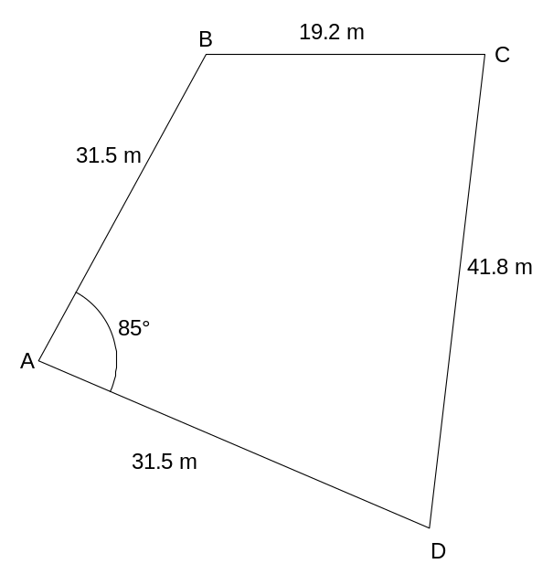The diagram shows a sketch of a block of land from a surveyor's notebook.

Assume ABCD is a polygon.

(Note: The diagram is not drawn to scale.)

- Find the distance BD.
[2 marks]

- Find the area of triangle ABD.
[2 marks]

- Find the area of the whole block of land ABCD.
[4 marks]

Question 8 [10 marks]
The weeds on the school oval were treated with a slow-acting poison and the number of weeds on the oval was checked and recorded at midday for the next 25 days. After t days, the number of weeds recorded, N(t), was found to be given by:

N(t) = 2t³ - 75t² + 600t + 3500

- Sketch a graph to show how the number of weeds varies from day to day, indicating clearly any maximum or minimum values.
[3 marks]

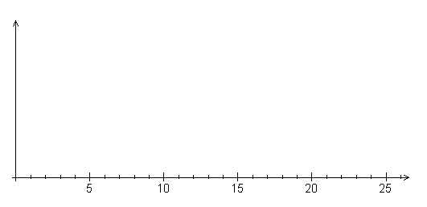
N(t)
t
- For how many of the 25 days was the recording more than 4 200 weeds? Show reasoning.
[4 marks]

- Write a short descriptive report on the success (or otherwise) of the weed-killing process during the above time period. This report should refer to the number of weeds recorded and the number of days since the poisoning occurred.
[3 marks]

Question 9 [6 marks]
Consider the following scattergraph showing the scores of fifteen students in a Geography test and a History test.
History
Geography
Test Scores
45
55
50
60
65
70
75
80
40
50
60
70
80

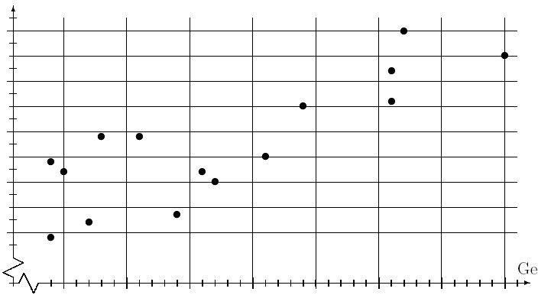

- John’s score was the second highest in the Geography test. What score did he get in History?
[1 mark]

- If G represents the Geography mark and H the corresponding History mark of a student, which of the following could be the equation of the line that best fits the scattergraph? Explain your answer.
[3 marks]
(A) H = 0.9G + 40
(B) H = −0.7G + 8
(C) H = 0.9G + 8

- Ashley was sick on the day that the Geography and History tests were held. She sat the Geography test during the lunch-hour the next day, and her History mark was estimated from her Geography mark. Ashley’s mark for Geography is 62. Use your answer for (c) to determine the mark Ashley was given for History.
[2 marks]

Question 10 [10 marks]
Frank is paying money into a machine at a long-term car park. He has a supply of $10 and $20 notes. The notes are fed into the machine one at a time.

- (i) Four ways that Frank can feed the notes into the machine to pay $40 are listed below:

$10, $10, $10, $10
$10, $10, $20
$10, $20, $10
$20, $10, $10

Find another way.
[1 mark]

- Are there more than 5 ways in which Frank can feed the notes to pay $40? Explain.
[1 mark]

- (i) Consider other amounts that Frank could pay and complete the table below.
[2 marks]

Amount | $10 | $20 | $30 | $40 | $50 | $60 | $70
Number of ways to feed into machine |  |  |  |  | 8

(ii) Describe the pattern in the number of ways to feed the notes into the machine.
[1 mark]

- How do you know the pattern will continue?
[3 marks]

- Find the number of ways to feed $10 and $20 notes into the machine to pay $130. Explain why the number of ways follows the pattern.
[2 marks]

ACKNOWLEDGEMENTS

Question 3: Australian Bureau of Statistics. (2003). Year book Australia 2003 (24.16: Children accessing the internet). Canberra: Author, p. 758.
Published by the Curriculum Council of Western Australia
27 Walters Drive
OSBORNE PARK WA 6017

